**WEEK 10– NO SQL Lab 2**

**(Tuesday, 24-01-2023)**

**Perform the following DB operations using MongoDB.**

* **Create a collection by name Customers with the following attributes Cust_id, Acc_Bal, Acc_Type.**

db.createCollection("Customer");



* **Insert at least 5 values into the table**

db.Customer.insert({Cust_id:1,Acc_bal:2000,Acc_type:"Z"});

db.Customer.insert({Cust_id:2,Acc_bal:1000,Acc_type:"Z"});

db.Customer.insert({Cust_id:3,Acc_bal:1500,Acc_type:"A"});

db.Customer.insert({Cust_id:4,Acc_bal:3500,Acc_type:"A"});

db.Customer.insert({Cust_id:1,Acc_bal:4000,Acc_type:"Z"});

db.Customer.insert({Cust_id:2,Acc_bal:2000,Acc_type:"A"});

db.Customer.insert({Cust_id:3,Acc_bal:4000,Acc_type:"Z"});

db.Customer.insert({Cust_id:4,Acc_bal:1000,Acc_type:"Z"});

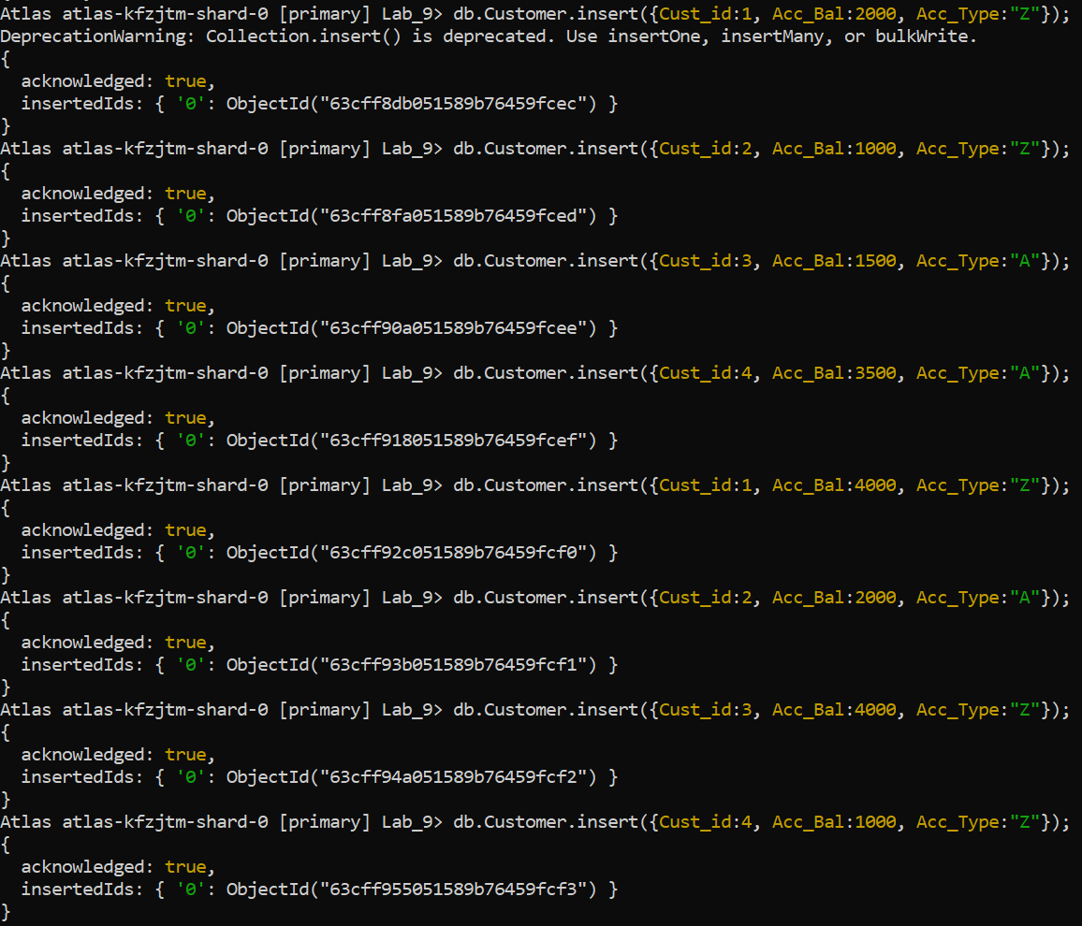

* **Write a query to display those records whose total account balance**

**is greater than 1200 of account type ‘Z’ for each customer_id.**

db.Customer.find({Acc_Type:”Z”, Acc_Bal:{$gt:1200}});

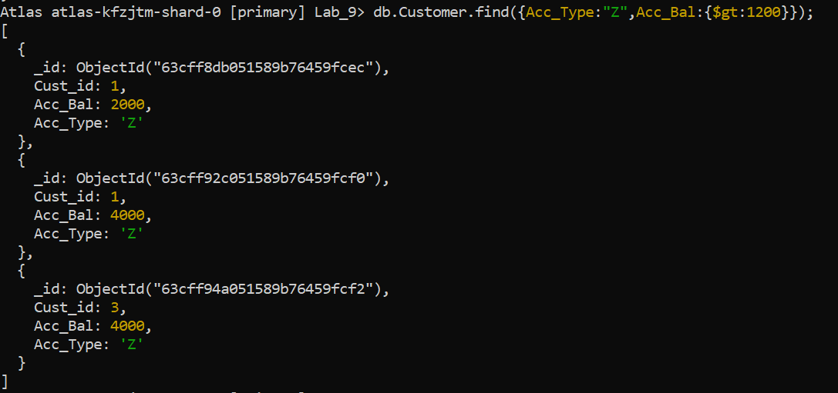

* **Determine Minimum and Maximum account balance for each customer_id.**

db.Customer.aggregrate([{$group:{_id:"$Cust_id","Acc_Bal":{$max:"$Acc_Bal"}}}])

db.Customer.aggregrate([{$group:{_id:"$Cust_id","Acc_Bal":{$min:"$Acc_Bal"}}}])

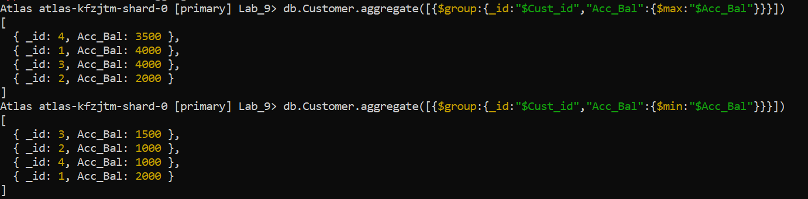

* **Export the created collection into local file system**

mongoexport mongodb+srv://dhiksha:<password>@cluster0.xbmgopf.mongodb.net/Lab_9 --collection=Customer -- out C:\Users\dhiks\Desktop\export\output.json



* **Drop the table**

db.Customer.drop();

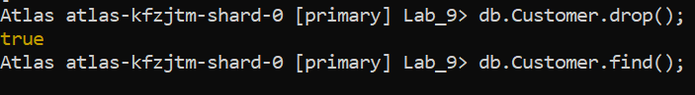

* **Import a given csv dataset from local file system into mongodb collection.**

mongoimport mongodb+srv://dhiksha:<password>@cluster0.xbmgopf.mongodb.net/Lab_9 --collection=new_Customer – type json –file C:\Users\dhiks\Desktop\export\output.json

